DEPT. OF ELECTRICAL & ELECTRONICS ENGINEERING

SRM INSTITUTE OF SCIENCE AND TECHNOLOGY, Kattankulathur – 603 203

|  |
| --- |
| Title of Experiment : **2. VERIFICATION OF ALL**  **THEOREMS- ( THEVENIN,**  **NORTON,**  **MAXIMUM POWER TRANSFER )** |
| Name of the candidate : DEBARGHYA BARIK    Register Number : RA2011026010022    Date of Experiment : 19. 10. 2020 |

|  |  |  |  |
| --- | --- | --- | --- |
| Sl.  No. | Marks Split up | Maximum marks  (50) | Marks obtained |
| 1 | Pre Lab questions | 5 |  |
| 2 | Preparation of observation | 15 |  |
| 3 | Execution of experiment | 15 |  |
| 4 | Calculation / Evaluation of Result | 10 |  |
| 5 | Post Lab questions | 5 |  |
|  | **Total** | **50** |  |

Staff Signature

**PRE LAB QUESTIONS**

1. **Define Lumped and distributed elements.**

**Ans:**

**Lumped element:**

**Lumped means** to unite into one aggregation, collection, or mass to unite into one aggregation, collection, or mass. So, lumped element means a section of transmission line designed so that electric or magnetic energy is concentrated in it at specified frequencies, and inductance or capacitance may therefore be regarded as concentrated in it, rather than distributed over the length of the line.

Examples: Resistor, Capacitor, Inductor etc.

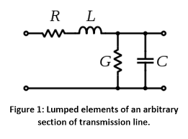

**Distributed element:**

**Distributed**-**element** model or transmission-line model of electrical circuits assumes that the attributes of the circuit (resistance, capacitance, and inductance) are **distributed** continuously throughout the material of the circuit.

**Examples: Transmission lines.**

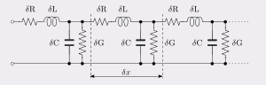

1. **State Thevenin’s theorem?**

**Ans:**

**Thevenin’s Theorem** states “Any two terminal linear circuit containing a large number of voltage and/or current sources and resistors can be replaced by a simple equivalent circuit containing a single voltage source and a series resistor”.

**3.State Norton’s theorem?**

**Ans:**

**Norton’s Theorem** states “Any two terminal linear circuit containing a large number of voltage and/or current sources and resistors can be replaced by a simple equivalent circuit containing a single current source in parallel with a resistor”.

1. **List the applications of Thevenin’s and Norton’s theorems?**

**Ans:**

**Application of Thevenin’s Theorem**

* To determine the **Change in Load Voltage:** To predict range of load voltage variation due to change in load resistance.
* To obtain **Norton’s equivalent circuit**.
* To determine the **Maximum power** that can be transferred to load from the network.

**Application of Norton’s Theorem**

* Norton’s theorem is used to **simplify a network** by introducing source transformation that is simplifying in terms of current instead of voltages.
* **The Norton’s equivalent circuit** is used to represent any network of linear sources and impedances at a given frequency.

1. **What are the different types of dependent or controlled sources?**

**Ans:**

**The different types of dependent or controlled sources are;**

* **Voltage Controlled Voltage Source (VCVS):** The source delivers the voltage as per the voltage of the dependent element.
* **Voltage Controlled Current Source (VCCS):** The source delivers current as per the voltage of the dependent sources.
* **Current Controlled Voltage Source (CCVS):** The source delivers the voltage as per the current of the dependent element.
* **Current Controlled Current Source (CCCS):** The source delivers the current as per the current of the dependent element.

|  |  |
| --- | --- |
| **Experiment No. 2 a) Date :** | **THEVENIN’S THEOREM** |

**Aim:**

To verify Thevenin’s theorem and to find the full load current for the given circuit.

**Apparatus Required:**

|  |  |  |  |
| --- | --- | --- | --- |
| Sl.No. | Apparatus | Range | Quantity |
| 1 | RPS (regulated power supply) | (0-30V) | 2 |
| 2 | Ammeter | (0-10mA) | 1 |
| 3 | Resistors | 1K, 330 | 3,1 |
| 4 | Bread Board | -- | Required |
| 5 | DRB | -- | 1 |

**Statement:**

Any linear bilateral, active two terminal network can be replaced by a equivalent voltage source (VTH). Thevenin’s voltage or VOC in series with looking pack resistance RTH.

**Precautions:**

* 1. Voltage control knob of RPS should be kept at minimum position.
  2. Current control knob of RPS should be kept at maximum position

**Procedure:**

* 1. Connections are given as per the circuit diagram.
  2. Set a particular value of voltage using RPS and note down the corresponding ammeter readings.

**To find VTH**

* 1. Remove the load resistance and measure the open circuit voltage using multimeter (VTH).

**To find RTH**

* 1. To find the Thevenin’s resistance, remove the RPS and short circuit it and find the RTH using multimeter.
  2. Give the connections for equivalent circuit and set VTH and RTH and note the corresponding ammeter reading.
  3. Verify Thevenins theorem.

**Theoretical and Practical Values**

|  |  |  |  |  |  |  |
| --- | --- | --- | --- | --- | --- | --- |
|  | E(V) | VTH(V) | RTH() |  | IL (mA) | |
| Circuit - I |  | Equivalent Circuit |
| Theoretical | 5  10  12  15  20 | 2.5  5  6  7.5  10 | 495  495  495  495  495 | 8.41  16.82  20.19  25.24  45.41 |  | 1.67  3.34  4.01  5.02  6.69 |
| Practical | 5  10  12  15  20 | 2.5  5  6  7.5  10 | 495  495  495  495  495 | 8.41  16.82  20.19  25.24  45.41 |  | 1.67  3.34  4.01  5.02  6.69 |

**Circuit - 1 : To find load current**

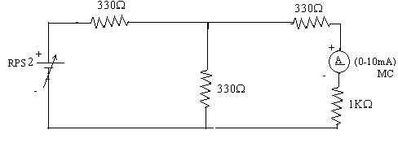

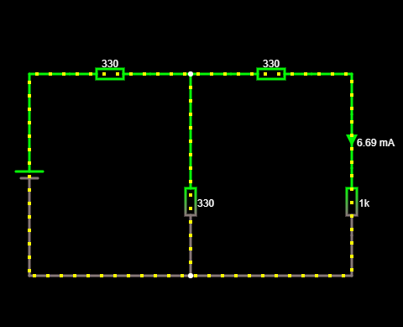

**To find VTH**

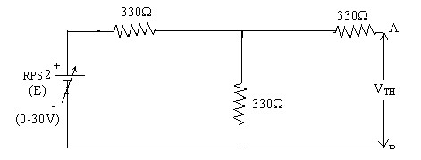

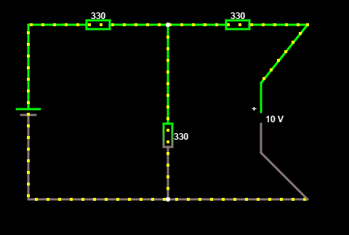

**To find RTH**

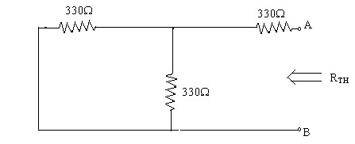

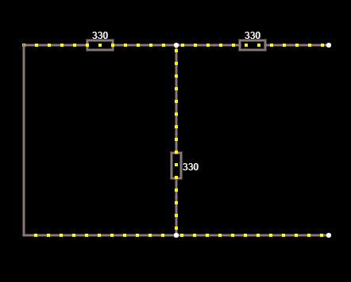

**Thevenin’s Equivalent circuit:**

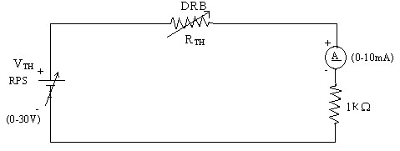

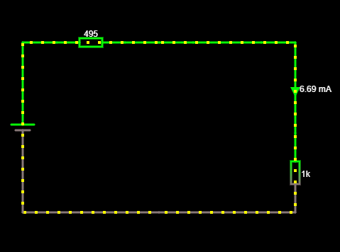

**Model Calculations:**

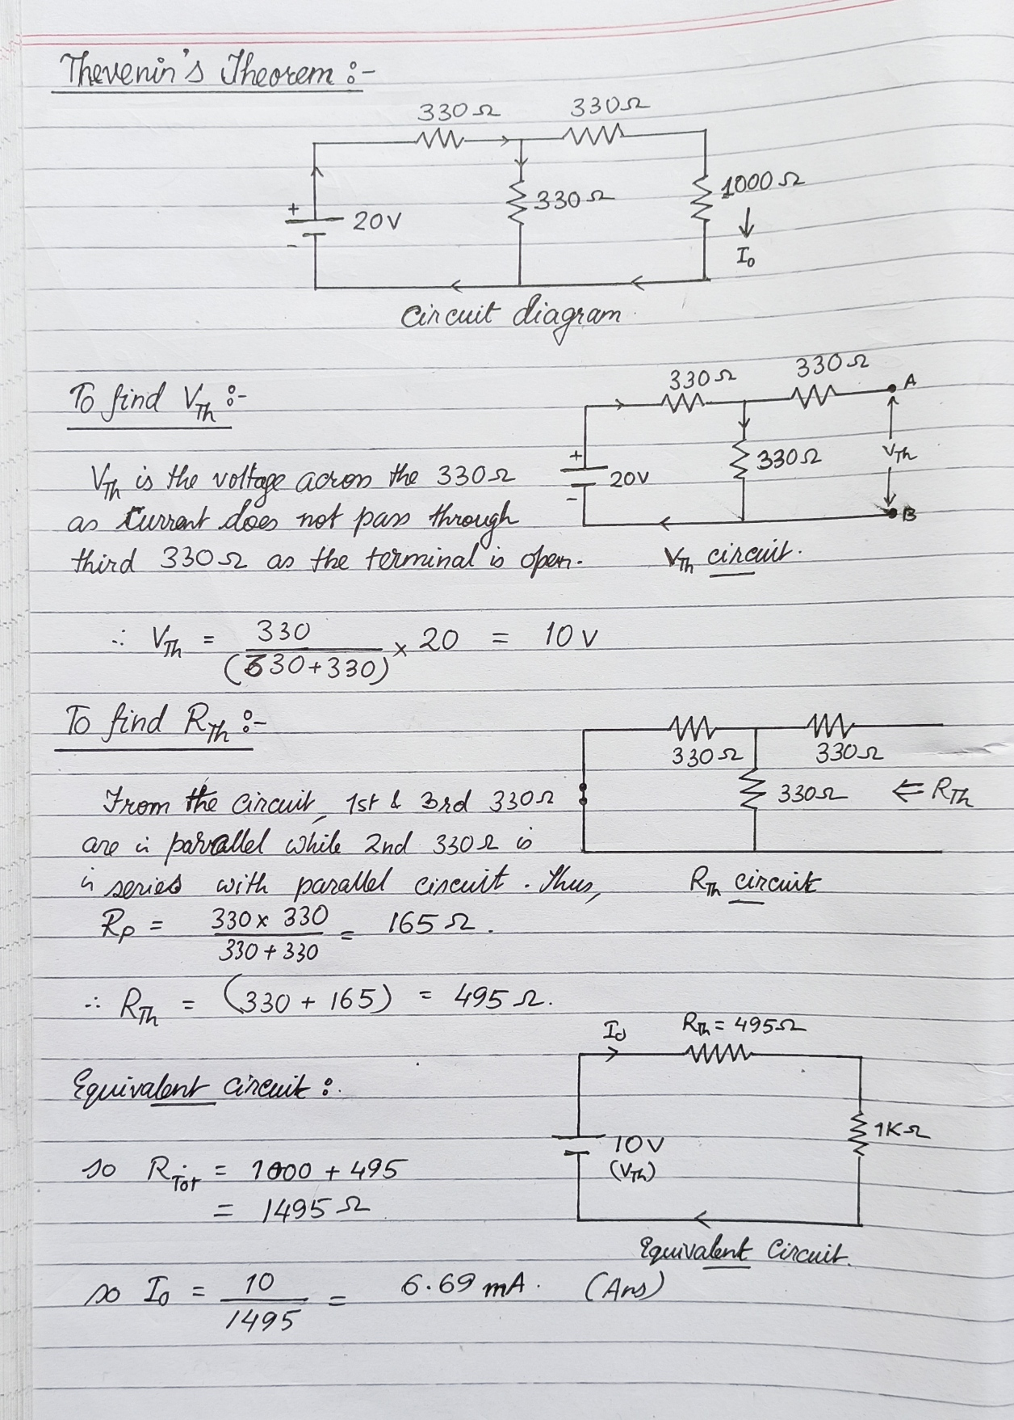

**Result: The Thevenin’s Theorem is verified using the theoretical calculations and practical e-circuit method.**

|  |  |
| --- | --- |
| **Experiment No. 2 b) Date :** | **VERIFICATION OF NORTON’S THEOREM** |

**Aim:**

To verify Norton’s theorem for the given circuit.

**Apparatus Required:**

|  |  |  |  |  |
| --- | --- | --- | --- | --- |
| Sl.No. |  | Apparatus | Range | Quantity |
| 1 | Ammeter |  | (0-10mA) MC  (0-30mA) MC | 1  1 |
| 2 | Resistors |  | 330, 1K | 3,1 |
| 3 | RPS |  | (0-30V) | 2 |
| 4 | Bread Board |  | -- | 1 |
| 5 | Wires |  | -- | Required |

**Statement:**

Any linear, bilateral, active two terminal network can be replaced by an equivalent current source (IN) in parallel with Norton’s resistance (RN)

**Precautions:**

1. Voltage control knob of RPS should be kept at minimum position.
2. Current control knob of RPS should be kept at maximum position.

**Procedure:**

1. Connections are given as per circuit diagram.
2. Set a particular value in RPS and note down the ammeter readings in the original circuit.

**To Find IN:**

1. Remove the load resistance and short circuit the terminals.
2. For the same RPS voltage note down the ammeter readings.

**To Find RN:**

1. Remove RPS and short circuit the terminal and remove the load and note down the resistance across the two terminals.

**Equivalent Circuit:**

1. Set IN and RN and note down the ammeter readings.
2. Verify Norton’s theorem.

**To find load current in circuit 1:**

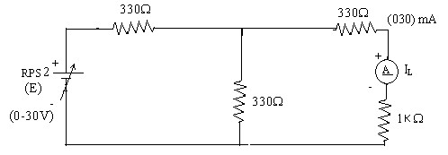



**To find IN**

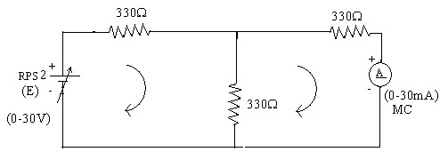

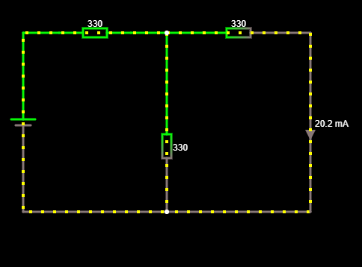

**To find RN**

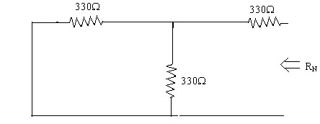



**Norton’s equivalent circuit**

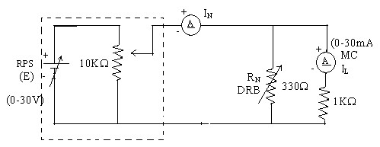

Constant current source

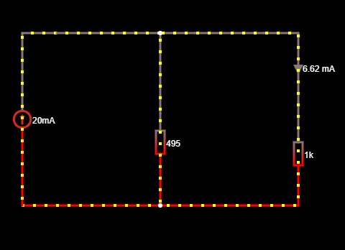

**Theoretical and Practical Values**

|  |  |  |  |  |  |
| --- | --- | --- | --- | --- | --- |
|  | E  (volts) | IN  (mA) | RN () | IL (mA) | |
| Circuit - I | Equivalent Circuit |
| Theoretical Values | 5  10  15  20  25 | 5.05  10.01  15.15  20.2  25.25 | 495  495  495  495  495 | 1.67  3.31  5.02  6.69  8.36 | 1.65  3.26  4.97  6.62  8.31 |
| Practical Values | 5  10  15  20  25 | 5.05  10.01  15.15  20.2  25.25 | 495  495  495  495  495 | 1.67  3.31  5.02  6.69  8.36 | 1.65  3.26  4.97  6.62    8.31 |

**Model Calculations:**

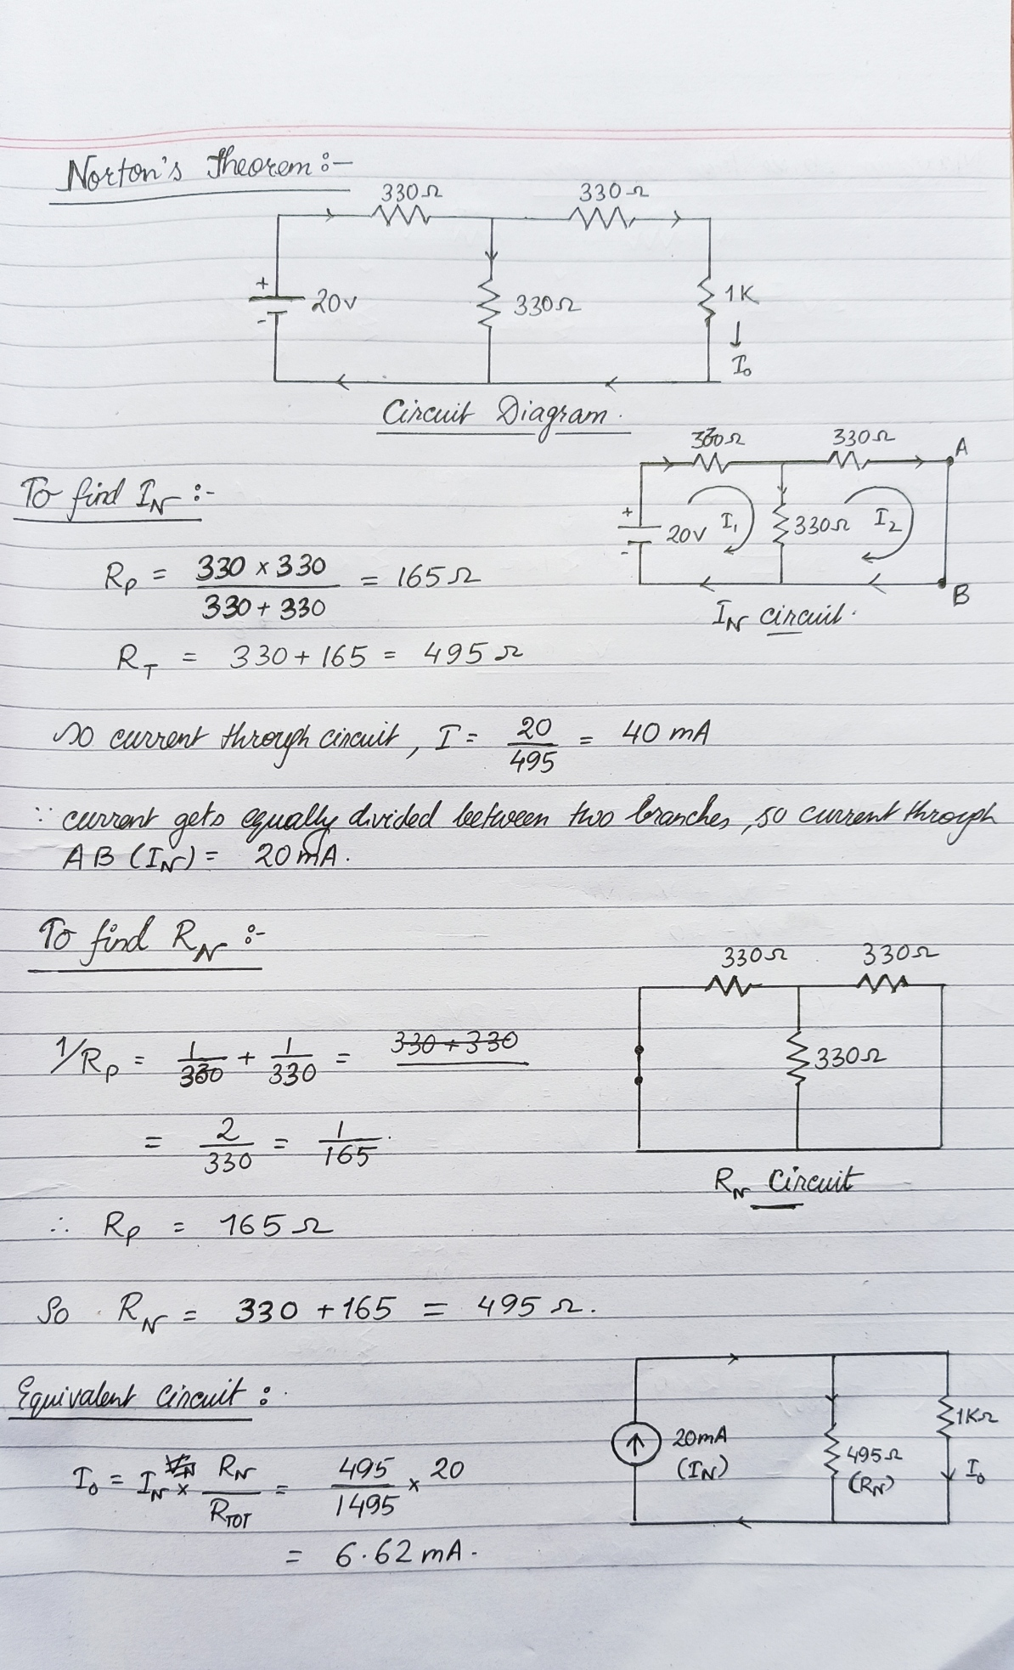

**Result: The Norton’s Theorem is verified using the theoretical calculations and practical e-circuit method.**

|  |  |
| --- | --- |
| **Experiment No. 2 c) Date :** | **VERIFICATION OF MAXIMUM POWER TRANSFER THEOREM** |

**Aim:**

To verify maximum power transfer theorem for the given circuit

**Apparatus Required:**

|  |  |  |  |
| --- | --- | --- | --- |
| Sl.No. | Apparatus | Range | Quantity |
| 1 | RPS | (0-30V) | 1 |
| 2 | Voltmeter | (0-10V) MC | 1 |
| 3 | Resistor | 1K, 1.3K, 3 | 3 |
| 4 | DRB | -- | 1 |
| 5 | Bread Board & wires | -- | Required |

**Statement:**

In a linear, bilateral circuit the maximum power will be transferred from source to the load when load resistance is equal to source resistance.

**Precautions:**

1. Voltage control knob of RPS should be kept at minimum position.
2. Current control knob of RPS should be kept at maximum position.

**Procedure: Circuit – I**

1. Connections are given as per the diagram and set a particular voltage in RPS.
2. Vary RL and note down the corresponding ammeter and voltmeter reading.
3. Repeat the procedure for different values of RL & Tabulate it.
4. Calculate the power for each value of RL.

**To find VTH:**

1. Remove the load, and determine the open circuit voltage using multimeter

(VTH)

**To find RTH:**

1. Remove the load and short circuit the voltage source (RPS).
2. Find the looking back resistance (RTH) using multimeter.

**Equivalent Circuit:**

1. Set VTH using RPS and RTH using DRB and note down the ammeter reading. 9. Calculate the power delivered to the load (RL = RTH)

10. Verify maximum transfer theorem.

**Circuit - 1**

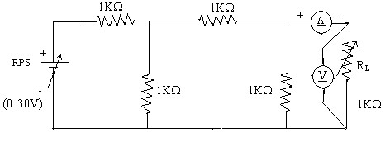

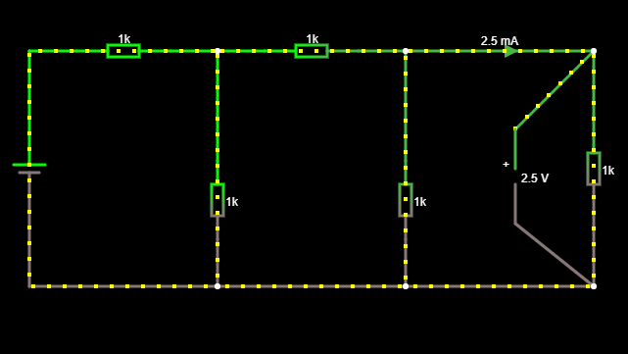

**To find VTH**

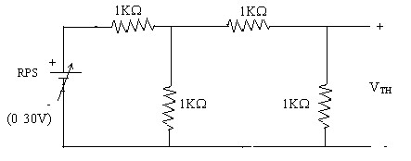

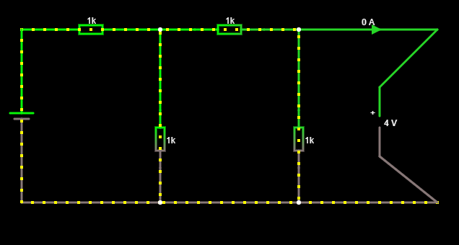

**To find RTH**

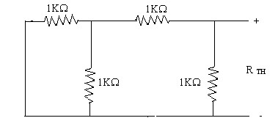

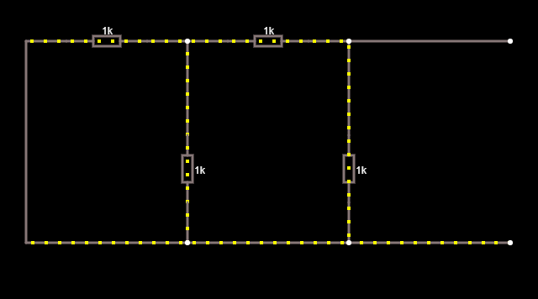

**Thevenin’s Equation Circuit**

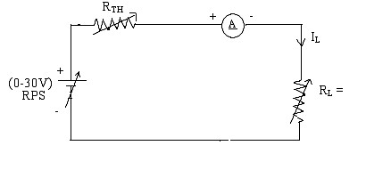

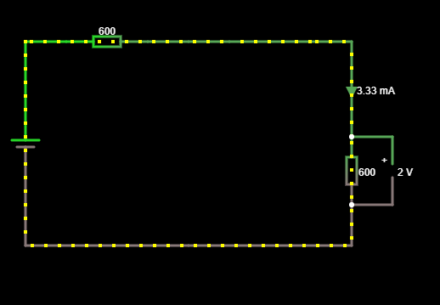

**Here RL = 600 ohm**

**Power vs RL**

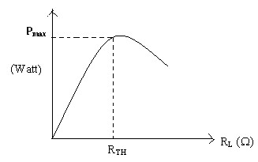

**Circuit – I**

|  |  |  |  |  |
| --- | --- | --- | --- | --- |
| **Sl.No.** | **RL (****)** | **I (mA)** | **V(V)** | **P=VI (watts)** |
| 1.  2.    3.  4.  5.  6.  7.  8.  9.  10. | 100  200  300  400  500  600  700  800  900  1000 | 5.71  5.00  4.44  4.00  3.63  3.33  3.07  2.85  2.66  2.50 | 0.57  1.00  1.30  1.60  1.80  2.00  2.10  2.20  2.30  2.50 | 3.20  5.00  5.70  6.40  6.50  6.60  6.40  6.20  6.10  6.25 |

**To find Thevenin’s equivalent circuit**

|  |  |  |  |  |
| --- | --- | --- | --- | --- |
|  | **VTH (V)** | **RTH (****)** | **IL (mA)** | **P (milli watts)** |
| **Theoretical**  **Value** | 4 | 600 | 3.33 | 6.6 |
| **Practical Value** | 4 | 600 | 3.33 | 6.6 |

**Model Calculations:**

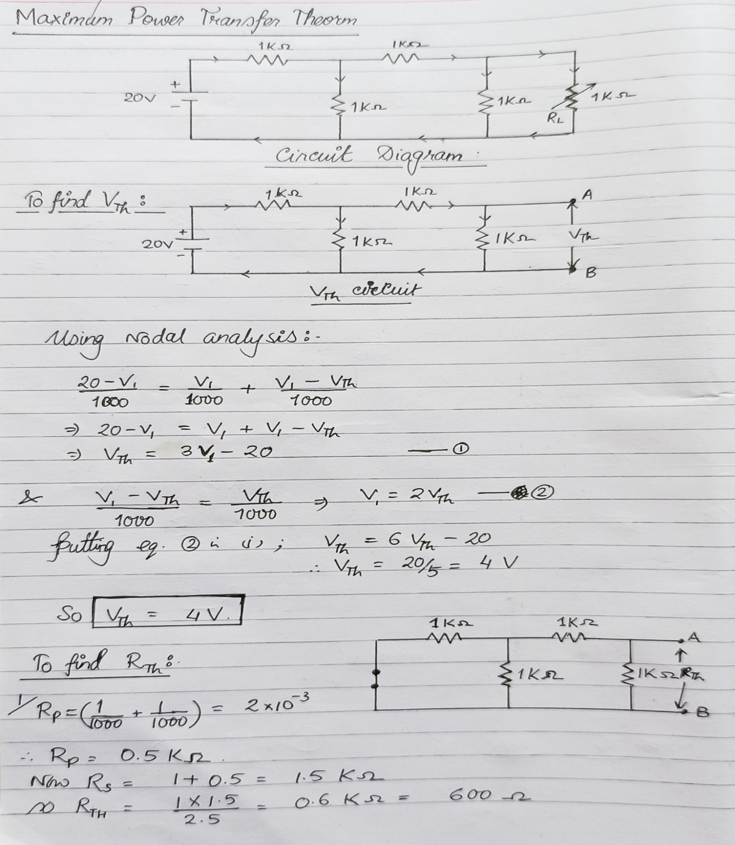

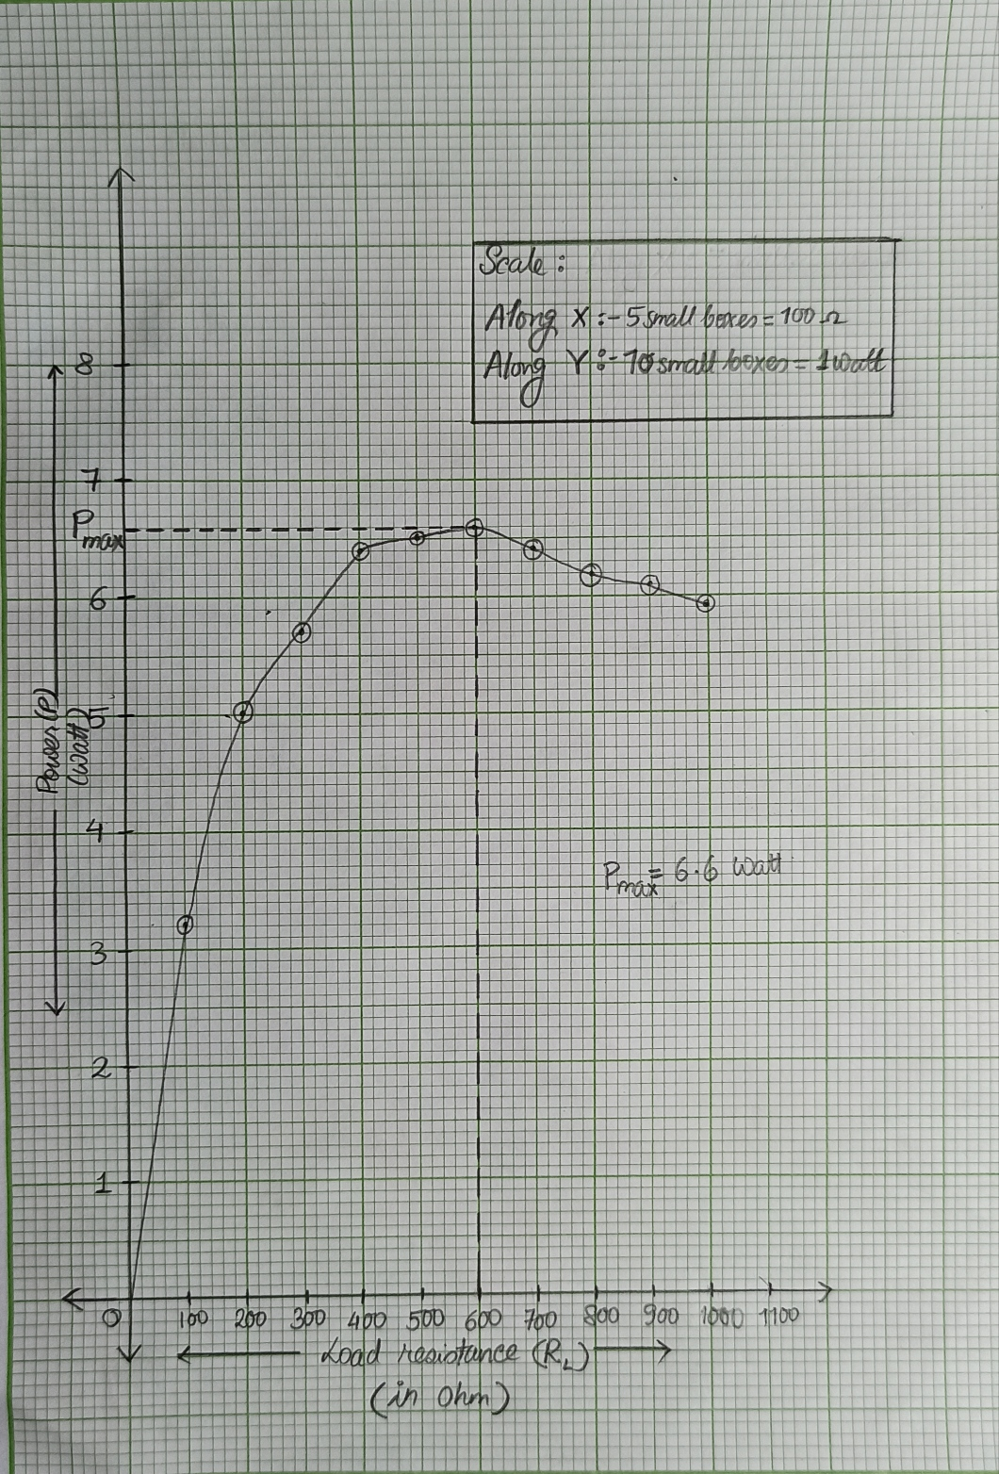

**Graph of Power (P) vs Load Resistance (RL)**

**Result: The Maximum Power Transfer Theorem is verified using the theoretical calculations with Graph and practical e-circuit method.**

**POST LAB QUESTIONS**

1. **State Thevenin’s Theorem.**

**Ans:**

**Thevenin’s Theorem** states “Any two terminal linear circuit containing a large number of voltage and/or current sources and resistors can be replaced by a simple equivalent circuit containing a single voltage source and a series resistor”.

1. **Draw the Thevenin’s equivalent circuit**

**Ans:**

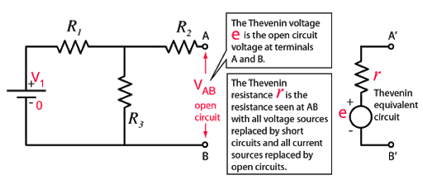

Diagram of Thevenin’s Equivalent Circuit.

1. **State maximum power transfer theorem.**

**Ans:**

Maximum Power Transfer Theorem states that “maximum power is transferred from the source to the load when the load resistance is equal to the Thevenin’s equivalent resistance.” that is RL = RTh [where RL = Load Resistance and RTh = Thevenin’s equivalent resistance.]

1. **Write some applications of maximum transfer theorem.**

**Ans:**

* The practical applications of maximum power transfer theorem include audio systems such as stereo, radio and public address. In these systems the resistance of the speaker is the load. The circuit that drives the speaker is power amplifier. The systems are typically optimized for maximum power to the speaker. Thus, the resistance of the speaker must be equal to the internal source resistance of the amplifier.
* It is also applicable on car engine where power needed for the motor starter will depend on motor resistance as well as battery resistance. While both of these resistances are equal, power transferred toward the engine will be maximum.

1. **Write the steps to find IN**

**Ans:**

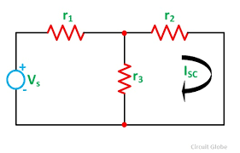

* Remove the RL and short terminals A and B.
* Now R2 and R3 are in parallel where as R1 in series. So total resistance

RT = R1+(R2 || R3)

= R1+((R2xR3)/(R2+R3))

* **Total current**, IT = V/RT

= V/(R1+((R2xR3)/(R2+R3)))

* Therefore, the **Norton’s current** between A and B;

IN = (V x R3)/((R1x(R2+R3)) + R2xR3)

1. **What are the steps to solve Maximum power transfer Theorem?**

**Ans:**

**Step 1**: Remove the load resistance of the circuit (consider open terminals at A & B)

**Step 2**: Find the value of VTh, using the nodal analysis. (for points A & B open terminals.)

**Step 3**: Find the Thevenin’s resistance (RTh) of the source network looking through the open-circuit load terminals.

**Step 4**: As per the maximum power transfer theorem, RTh is the load resistance of the network, that is RTh = RL that allows maximum power transfer.

**Step 5**: Maximum Power Transfer is calculated by the below equation (Pmax) = V2Th / 4RTh

**Step 6**: A PL vs RL graph is to be plotted.

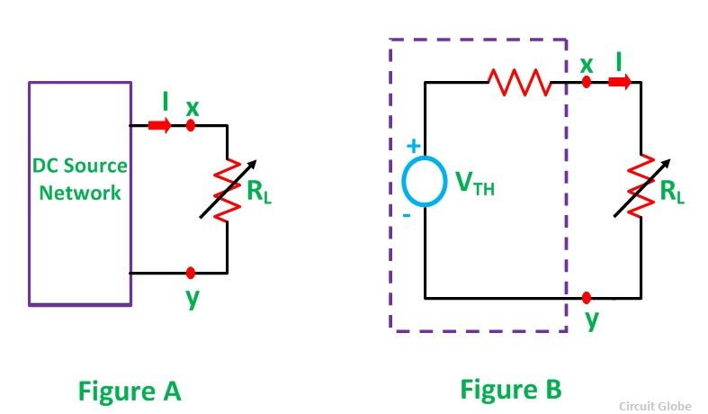

Circuit diagram for Max Power Transfer Theorem.